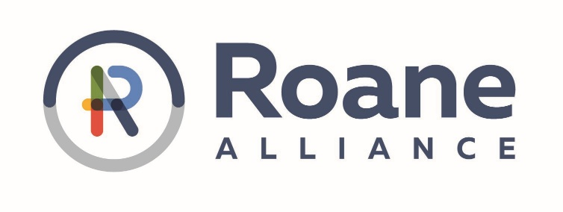

Job Title: Marketing & Communications Director
Organization: The Roane Alliance
Location: Roane County, TN
Reports To: President & CEO

Position Summary:
The Roane Alliance is seeking a creative and strategic Marketing & Communications Director to enhance our brand, engage our community, and promote economic growth in Roane County. This role is responsible for managing the Alliance’s marketing efforts, including social media, website content, publications, and communications that support our mission of economic development, tourism, and community engagement through the Roane Chamber.

Key Responsibilities:

Marketing & Communications:
- Develop and implement marketing and communication strategies to promote The Roane Alliance, its programs, and key initiatives.
- Create engaging content for press releases, email campaigns, and promotional materials.
- Maintain brand consistency across all materials and platforms.

Social Media & Digital Marketing:
- Manage and grow The Roane Alliance’s presence on social media (Facebook, Instagram, LinkedIn, Twitter, etc.) through engaging content and strategic campaigns.
- Create, schedule, and monitor posts, ensuring content aligns with the organization’s mission and current initiatives.
- Engage with followers, respond to inquiries, and foster an online community.
- Analyze social media metrics to optimize engagement and reach.

Website Management:
- Update and maintain website content, ensuring information is current, relevant, and visually appealing.
- Work with web developers and vendors as needed for website improvements and functionality updates.
- Optimize website for search engines (SEO) and user experience.

Event Promotion & Community Engagement:
- Support marketing efforts for major events, including the Roane Gala, Roane Chamber Events, and business development initiatives.
- Collaborate on event materials such as flyers, programs, and sponsorship packages.
- Assist in public relations efforts, including media outreach and community partnerships.
- Capture high-quality photos and videos at events, ensuring proper lighting, focus, and angles, and edit content for use in marketing materials, social media, and promotional campaigns.
- Other duties as assigned.

Qualifications & Skills:
- Bachelor’s degree in Marketing, Communications, Public Relations, or a related field (or equivalent experience) preferred.
- 1-3 years of experience in marketing, social media management, or communications.
- Strong writing, editing, and storytelling skills.
- Proficiency in graphic design tools (Canva, Adobe Suite) and website management platforms (WordPress, Squarespace, etc.).
- Knowledge of digital marketing, including SEO, email marketing, and analytics.
- Ability to manage multiple projects, meet deadlines, and work independently.
- Passion for community engagement and economic development in Roane County.

Preferred Experience:
- Familiarity with economic development, tourism, or nonprofit marketing.
- Experience with video and photo content creation and editing.
- Knowledge of analytics tools (Google Analytics, Facebook Insights, etc.).

Benefits & Work Environment:
- Competitive salary based on experience.
- Opportunities for professional development and networking.
- Collaborative and mission-driven work environment.
If you’re a creative and driven marketing professional who wants to make a meaningful impact in Roane County, we’d love to hear from you!
To Apply: Send your resume, cover letter, and samples of your work (social media posts, design materials, or writing samples) to jsnow@roanealliance.org and dcarlock@roanealliance.org with Marketing & Communications Director Resume in the Subject line, or hand deliver to:
The Roane Alliance
1209 N. Kentucky Street
Kingston, TN 37763

